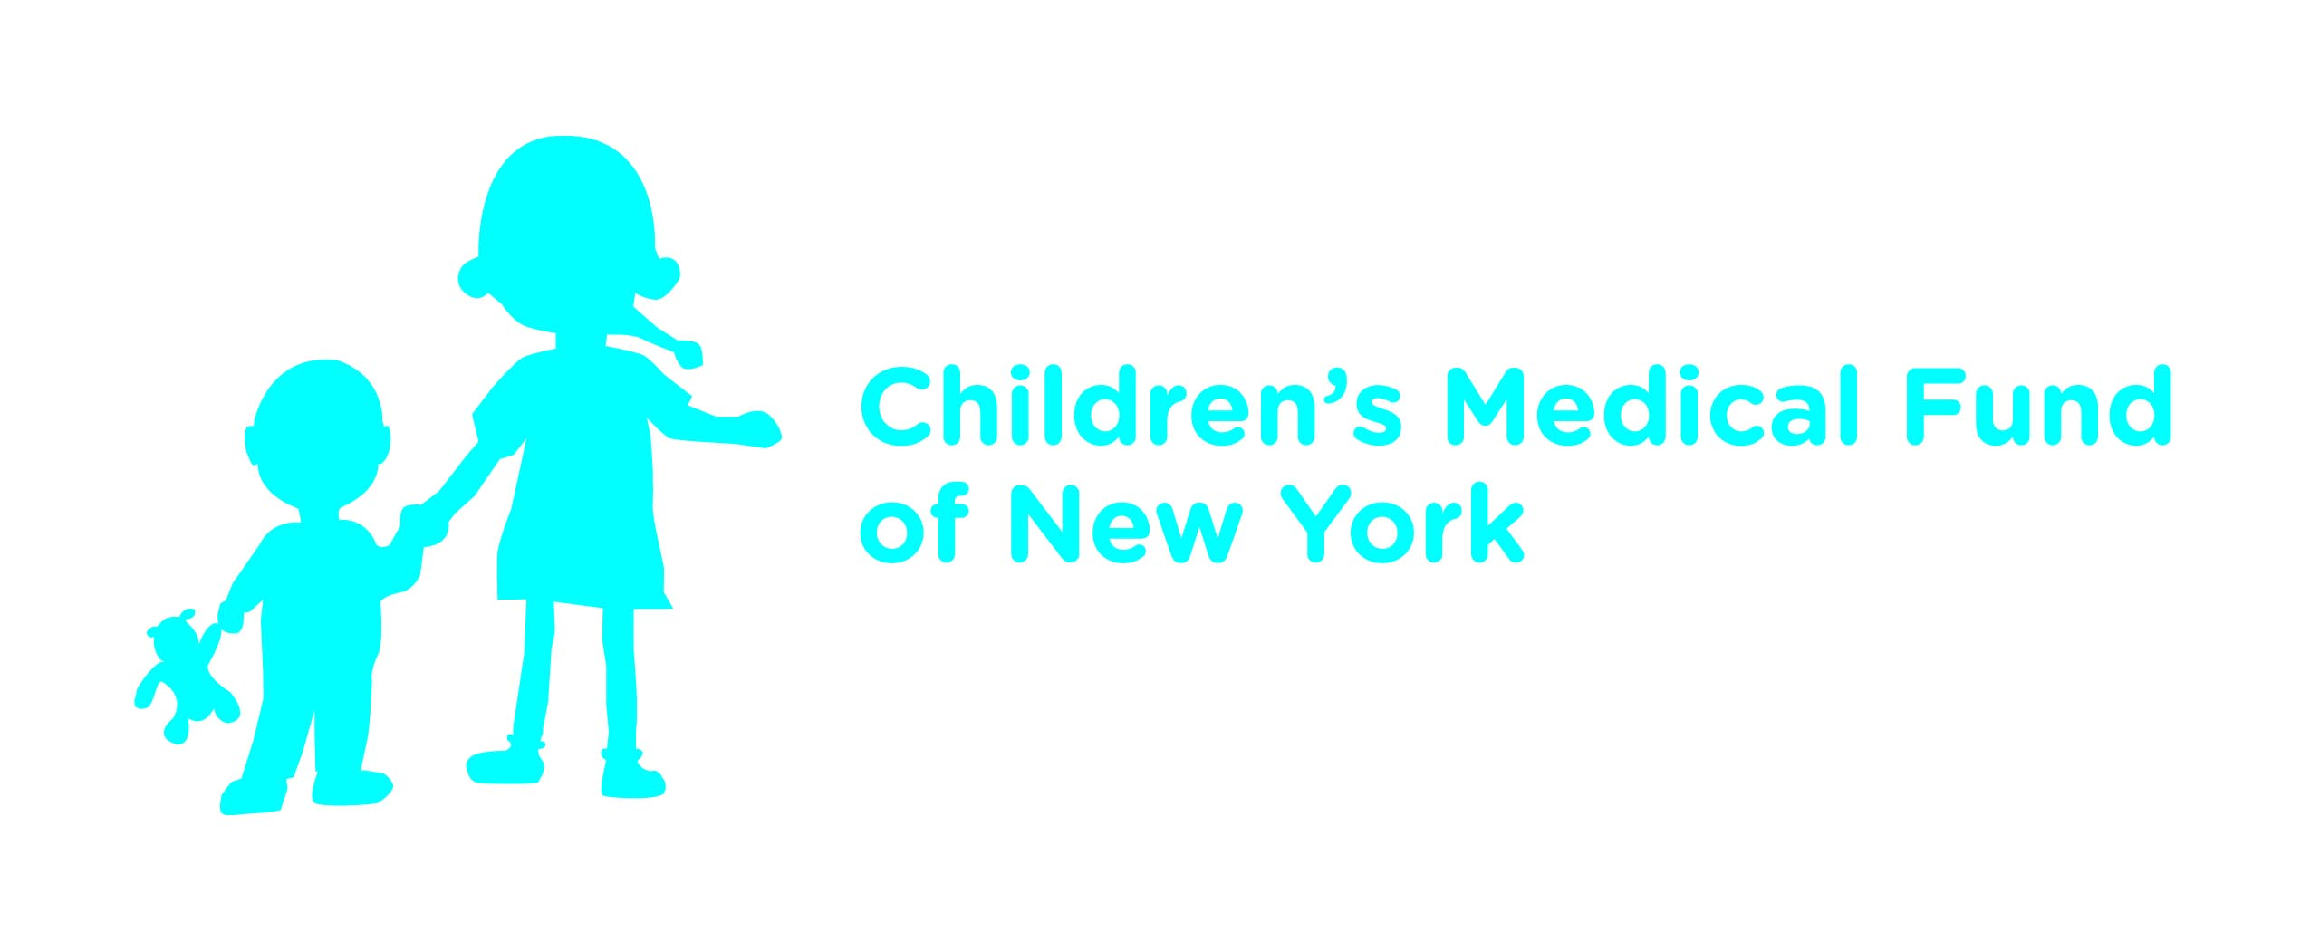
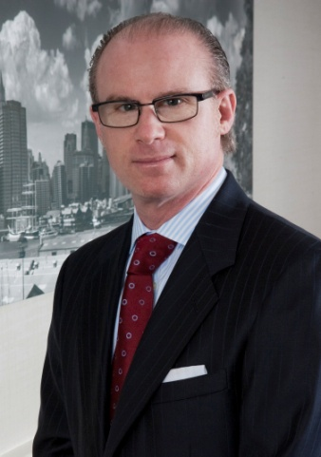
RANDY ZELIN, ESQ. NAMED MEN’S DIVISION PRESIDENT OF CHILDREN’S MEDICAL FUND OF NEW YORK

Randy Zelin has been named Men’s Division President of Children’s Medical Fund of New York (www.cmfny.org). The Men’s Division hosts a variety of events including our Annual Golf & Tennis Charity Classic, Children’s Fashion Show, Steaks & Sticks, and Family Fun Day.

The appointment, announced by Men’s Division President Emeritus Neil Schorr, was effective June 17, 2013.

A longstanding CMF board member since 2005, Randy has been an integral part of Children’s Medical Fund and our efforts to support critically ill children and their families. Randy and his firm Moritt Hock & Hamroff LLP are a constant source of support by sponsoring many of our events each year.

Randy has instilled in his children the values of helping others and giving back. They volunteer at our events and have also participated in the fashion show. This is a wonderful example of children helping children.

Randy’s appointment will bring a level of enthusiasm to Children’s Medical Fund,” said CMF Chairman Blumenfeld. “We are extremely happy to have him serve as Men’s Division President.”

CMF is one of the single largest contributors to Steven & Alexandra Cohen Children’s Medical Center of New York.

Children's Medical Fund of New York (CMF) is a 501 © (3) not for profit organization that ensures Children on Long Island and in the New York metropolitan area have access to the best available Pediatric care by raising funds to help build and equip medical facilities and sponsor vital programs at Cohen Children’s Medical Center of New York.

